Instructions to Play The Witch and the Potions;

1. Start the game by pressing the green flag on top left hand side of the screen, you can extend the screen by clicking on the expand  button

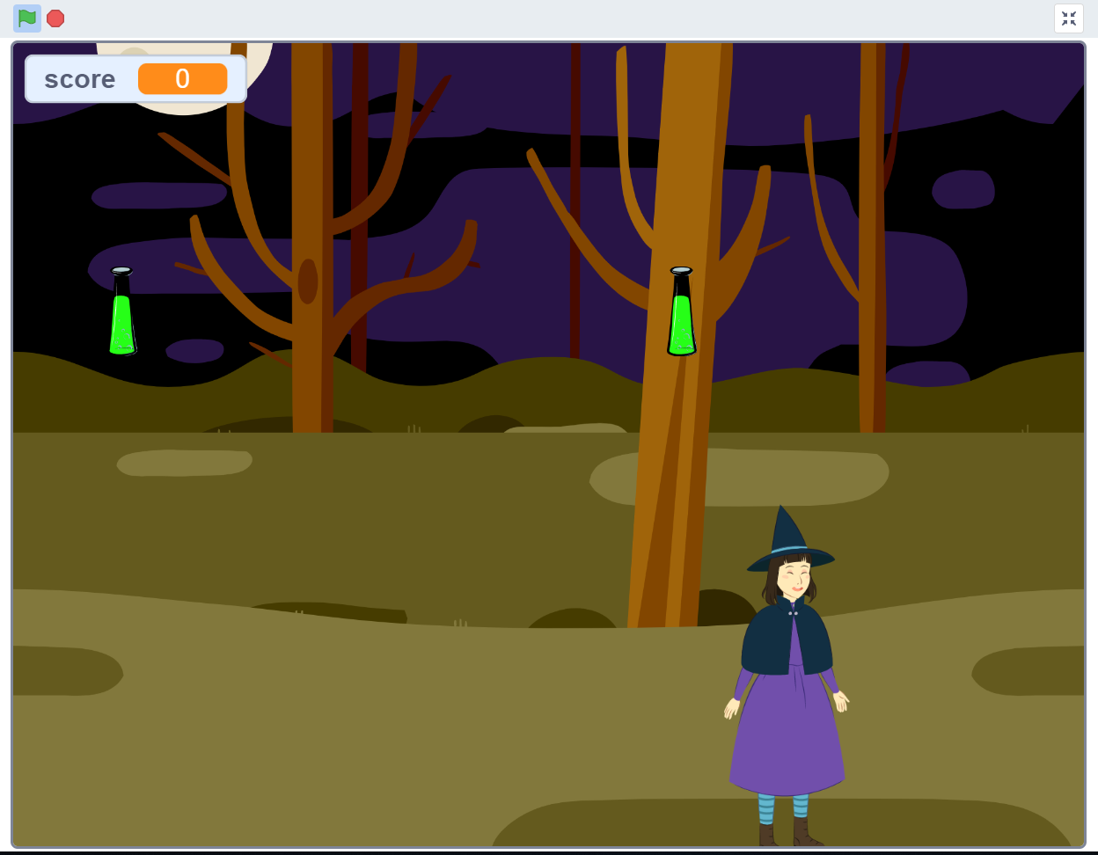

1. Move the right arrow key on the keyboard to move the witch to the right and left arrow key to move her to the left.
2. Your aim is to catch as many potions as you can that are falling from the sky. Each time you touch a potion it adds 1 point to your score which you can see on the top left hand of the screen. Every time you catch a potion, a magic sound is played.

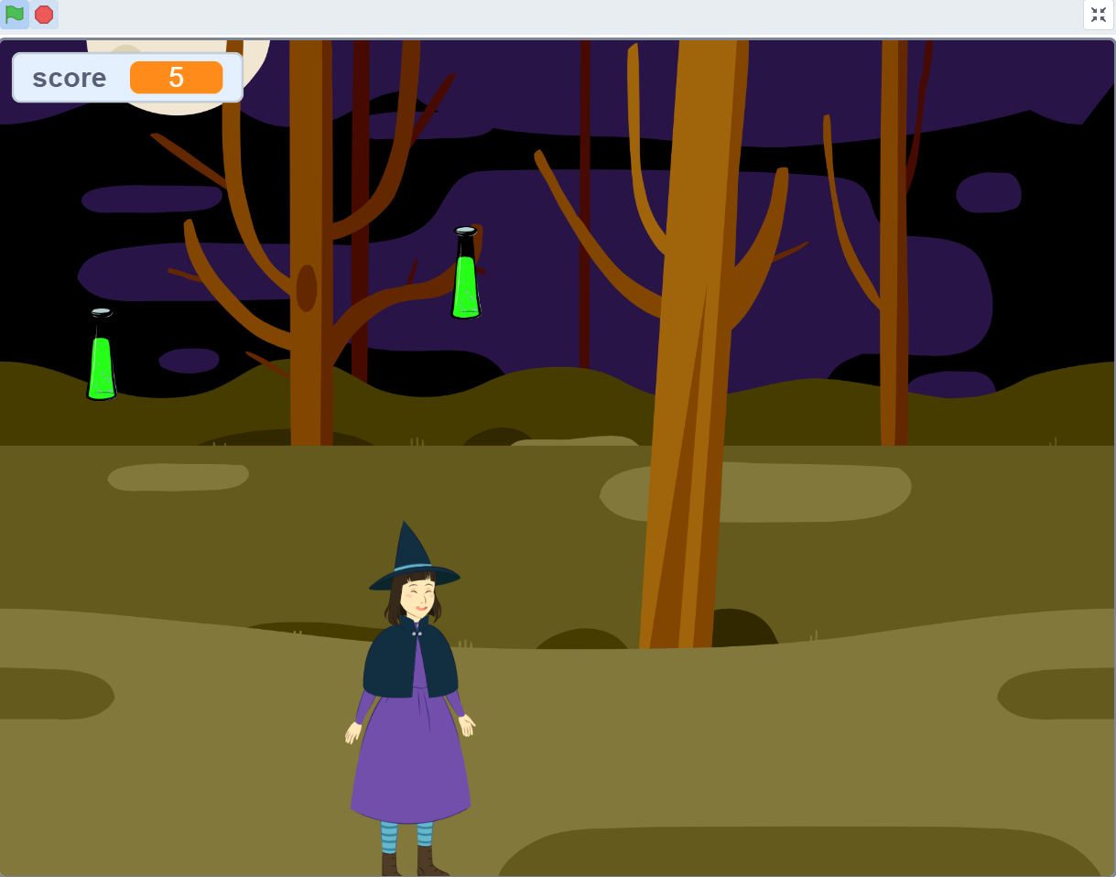

1. When your score reaches more than 15, you win the game and below sign with a cheer sound appears!

